**COLLEGE OF ENGINEERING**

Design Document

**GADGET: A Really Cool Thingamabob**

Submitted To:

Professor Dennis Silage

Senior Design Project I and II

Temple University

College of Engineering

1947 North 12th Street

Philadelphia, Pennsylvania 19122

December 2, 2013



Prepared By:

J. Doe, J. Smith, M. Smith, and Y. Smith

Faculty Advisor(s): Professor John Smith

Industrial Advisor(s): James Smith, Corona Corporation

Team Name

Temple University

College of Engineering

1947 North 12th Street

Philadelphia, Pennsylvania 19122

For further information, please contact Dr. Dennis Silage (email: silage@temple.edu).



|  |  |  |
| --- | --- | --- |
| **Team SD1-01** | **SIPA** |  |
| **Team Members** | Philip Agbede, Izuchukwu Dike, Ajo Maret and Olushola Olatujoye | |
| **Advisor(s)** | Fatehy El-Turky | |
| **Coordinator** | Frank Higgins | |
| **Department(s)** | Electrical and Computer Engineering | |
| **Project Title** | High Voltage Switch Mode Power Supply for Three-Phase AC Aircraft Systems | |
| **Abstract** | This project involves the design and implementation of a Three Phase Power Converter (AC/DC/AC). The designed system will convert an AC voltage of 110 Volt at 60Hz frequency to DC voltage by using a Diode Bridge Rectifier, and a capacitive filter which will help in stabilizing the output DC voltage that is produced. After that the system provides the gate drive signal to the three phase pulse width modulation (PWM) inverter. The pulse width modulation signal/code control algorithm will be developed in Matlab/Simulink/Real-time workshop using block diagram. The code generated in Matlab will be converted to C language by the real-time workshop (RTW) and then transferred to the DSP board by using the code composer studio (CCS). The Three Phase IGBT (insulated Gate Bipolar Transistor) uses the DC voltage produced by the diode bridge rectifier and the gate driver signal to produce a sinusoidal AC output. An inductive and a capacitive (LC) filter will be designed to help produce a pure sinusoidal output waveform. The aim of this project is to implement a design that is capable of producing 10KW of power at 110 volt at output. | |
| **URL** | https://sites.google.com/a/temple.edu/team-elect/ | |

**Executive Summary**

The executive summary in your SD document should be placed just after the table of contents and other front-matter lists. In contrast to the technical and implementation summary section near the end of the document, the executive summary provides a relatively nontechnical overview of the design document, stressing aspects that support business decisions (rather than technical or implementation details). Executive readers may decide whether to support your project largely on the basis of this summary, so it needs to be self-contained and as compelling as you can honestly make it.

Unlike other sections of the design document, the executive summary for SD should just fill one *single-spaced* page. The summary must include *exactly four unnumbered paragraphs*, *without any subheads*. You can use bullets within each paragraph, however. Use literary devices as described in Markel Chapter 9 to make the summary read smoothly and coherently. Writing concisely and coherently is challenging, so allow time for multiple revisions and edits.

Table 1. Required content of four paragraphs in executive summary

|  |  |  |
| --- | --- | --- |
| Para. | Content description | Main source(s) for proposal-stage version of exec. summary |
| 1 | Summarize at a high level the challenge the project aims to meet; in many cases this will be an existing problem you wish to help solve. Aim to motivate support for your *project* — not for your specific technical approach. | *Overall Objectives* and *Historical and Economic Perspective* in **Problem Statement** section |
| 2 | Identify key design requirements and constraints, and describe in quantitative terms the technical challenges of the project. Using “quantitative terms” does not mean guessing at final numbers in the proposal stage; it means using terms that can later be quantified where appropriate. | Main discussion of **Requirements and Constraints** (for the proposed solution concept) in that section of design document |
| 3 | Briefly explain your technical design for executives, describing how it will deliver required functionality while meeting key design constraints. Don’t dwell on technical or implementation details, but do briefly describe and justify any significantly novel aspects of your approach.  *Note:* In later stages of the project, this paragraph should be revised to evaluate the design retrospectively based on extensive testing. This paragraph will then also summarize any changes still needed to make the project work. | *Proposed Solution Concept* in **Problem Statement** section.  Details of proposed design in the **Design Approach** section |
| 4 | The last part of the executive summary *realistically* touts the project’s potential for accomplishment:   * Immediate business impact if successful * Possible broader impact, if any (e.g., new uses or new markets enabled) * Social-environmental contributions, if any   Any serious reservations about these impacts should be acknowledged frankly for executive consideration. | *Implementations of Project Success* in **Problem Statement** section  [Technical] **Summary** section at end of document |

**TABLE OF CONTENTS**

1. Problem 1

2. DESIGN REQUIREMENTS 1

2.1. Functional Design Constraints 1

2.2. Non-Functional Design Constraints 3

3. APPROACH 3

3.1. DC Power Supplies 4

3.2. Hardware Design 4

3.3. Software Design 5

4. EVALUATION 5

4.1. Test Specification 5

4.2. Test Certification – Simulation 5

4.3. Test Certification – Hardware 6

4.4. Test Certification – Software 6

5. SUMMARY AND FUTURE WORK 6

6. ACKNOWLEDGEMENTS 6

7. REFERENCES 6

APPENDIX A: Product SPECIFICATION 7

APPENDIX B: SOME INTERESTING RELEVANT DERIVATION 8

# Problem

The Problem Statement section starts by exploring both technical and nontechnical aspects of the project’s problem or challenge. This exploration includes both *documented library-database research* and *independent analysis* by your project team. This exploration leads to a list of candidate design solutions, and concludes with your reasoned selection of a **proposed** **solution concept** from that list. The rest of the document will then focus on the detailed design, implementation, testing, and refinement of that proposed concept.

The Problem Statement section should be organized into exactly the following level-two headers (Heading 2 style), with additional topic-specific lower-level subheads as necessary:

* Overall Objectives
* Historical and Economic Perspective
* Candidate Solutions
* Proposed Solution Concept
* Major Design and Implementation Challenges
* Implications of Project Success

The following paragraphs detail the content of these required subsections.

## Overall Objectives

Help the reader understand and approve of your overall project (vs. the specifics of your approach).

* Concisely explain what your team hopes to accomplish.
* Describe a specific economic scenario to which the project is oriented: product commercialization, nonprofit technology transfer, etc.

## Historical and Economic Perspective

Provide a background overview of the problem or challenge you are researching:

* Help readers understand the significance of the problem.
* In addition to a technological history, include relevant societal, ecological, and other factors that will affect your choice of a proposed design solution.
* Explain if and how your project seeks a solution that differs from what is currently available.
* If applicable, provide a market analysis (size, revenues, price, etc.) and competitive product analysis.

## Candidate Solutions

Explore potential solutions in an open-minded way, so as not to prematurely settle on a possibly inferior solution:

* List possible technical and nontechnical solutions to the overall problem.
* Briefly mention and dismiss any apparent solutions that are clearly not feasible, to show that you considered them (and to enable your reviewers to challenge your dismissal of them).
* Methodically discuss the pros and cons of the remaining candidate solutions along with any tradeoffs or other relationships between them.

## Proposed Solution Concept

Based on the preceding subsection:

* Propose a particular solution (or complementary combination of solutions) that you want your project to pursue.
* Justify your choice by explaining how the previously discussed pros and cons make your solution concept preferable to other alternatives.

## Major Design and Implementation Challenges

Concisely describe the main hurdles to be overcome in designing and implementing your proposed solution concept:

* First do so in nontechnical terms.
* Then provide a more specific technical formulation of the major challenges.

Include only challenges that any team would have to overcome. Challenges due to your team’s lack of knowledge or experience, outside commitments, interpersonal issues, or other difficulties would be addressed to your manager in a separate memo.

## Implications of Project Success

Describe what may realistically be expected to happen if your project is successful. Style this prediction as a businesslike projection, not a world-changing manifesto. Give thoughtful attention to the following aspects of this prediction:

* Implications of the product or method itself
* Business implications for your organization in particular
* Implications, if any, to the overall market
* Environmental and related issues, if any
* Social justice and related issues, if any

In this section, you will define the problem you are addressing, explain its significance, and discuss the impact of your solution (not how you are going to solve the problem, but what will happen if you solve the problem). Start with a general overview, background, etc., and then get progressively more detailed. This section must be at least two pages long.

# DESIGN REQUIREMENTS

Start with an introductory paragraph or two. Then you will list your specific design constraints, followed by an explanation. This section should be at least three pages long.

Design constraints must be quantitative and must be testable. The section on evaluation will describe the tests you use to verify your design constraints.

## Functional Design Constraints

Our five functional design constraints are shown in Table 2. Each team must have five functional design constraints that adequately constrain the design of the physical system (including software). Functional design constraints typically relate to the performance of the system. Note the format of the table and the use of a cross-reference in the text above.

You will need several paragraphs explaining these design constraints. Typically these are explained in groups since design constraints are often interrelated. Use constraints that relate to well-known standards (such as UL or FCC specs), and be sure to explain these specifications.

|  |  |
| --- | --- |
| **Name** | **Description** |
| Signal to Noise Ratio | We will achieve a signal-to-noise ratio of 30 dB or greater, and demonstrate that this exceeds performance of existing technology. |
| Communications Protocol | We will use an RS-232C interface for communications between the module and the base station. |
| Accuracy | This system’s incorrect classification rate will not exceed 3.5% on data whose SNR exceeds 15 dB. |
| Robustness | The imposter acceptance rate will not exceed 3% on data whose SNR exceeds 10 dB. |
| Transmission Distance | Our base station will communicate with the server at a maximum distance of 100 feet with a bit error rate not to exceed 1e-05. |

Table 2. Functional design constraints for the GADGET system.

## Non-Functional Design Constraints

In the ABET handbook on accrediting engineering programs, it states:

“Students must be prepared for engineering practice through the curriculum culminating in a major design experience based on the knowledge and skills acquired in earlier course work and incorporating engineering standards and realistic constraints that include most of the following considerations: economic; environmental; sustainability; manufacturability; ethical; health and safety; social; and political.”

|  |  |  |
| --- | --- | --- |
| **Type** | **Name** | **Description** |
| Economic | Cost | The expected retail for this price is $100 based on a parts cost of $25. |
| Environmental | Power | The main processor unit will dissipate no more than 3 Watts. |
| Sustainability | Reliability | This system will be designed to operate over a five year period without failure. The expected battery life is seven years and is the only part requiring regular maintenance. |
| Manufacturability | Size | The physical dimensions will be 3” high, 4” wide, and 6” deep. |
| Health and Safety | Safety | We will conform to UL Specification 631 which requires that this unit not deliver an electrical shock to the user under …, and UL Specification 837 which requires a …. |

Table 3. Non-functional design constraints for the GADGET system.

Every senior design project must include five design constraints that address some of these issues. See the lecture notes for some ideas on the types of non-functional design constraints that you can use. An example of these are shown in Table 3. These typically include things like size, power, weight, and cost. Every project need not address all of the factors specified by ABET. However, all projects must have five design constraints that relate to these issues.

After you provide these constraints, some explanation will be required.

# APPROACH

In this section, you explain your approach in great detail. This will be the single largest section in the document, often 20 or 30 pages long. It will contain a comprehensive explanation of your design, including theory and practice. It should be somewhat self-contained so that a student with a background similar to yours can understand it. It will most likely use two levels of subsections (e.g., 3.1 and 3.1.1). Only the first level of subsections (e.g., 3.1) needs to be included in the Table of Contents.

Figures should appear as shown below and be referenced in the text as Figure 1. Similarly, tables should be included in the text and be referenced as Table 1 (see the examples in the previous section). All text in figures and tables, including the captions, use a 9 pt. Times New Roman font (as does the text).

Equations in your document should appear as shown below with the equation number in parentheses to the right of the equation. Use a medium-sized font — one that matches the rest of the document:

We will follow APA format for citations. See REFERENCES for more information on the format. References are cited in the text using an in-line style. For example, the best way of developing a DC power supply is to use a Duracell battery (Anderson, 2005). Many approaches exist for developing such things, but my favorite one is an approach which is really space efficient (Anderson, *et al.*, 2003). Note that APA style does not require the use of cross-references (Armony & Dolan, 2002).

## DC Power Supplies

You should probably start this section with a general overview of the primary technology you are developing. Then you can transition into the specifics of the hardware and software design.

[Some filler text here … Some filler text here … Some filler text here … Some filler text here … Some filler text here … Some filler text here … Some filler text here … Some filler text here … Some filler text here … Some filler text here … Some filler text here … Some filler text here … Some filler text here …]

[Some filler text here … Some filler text here … Some filler text here … Some filler text here … Some filler text here … Some filler text here … Some filler text here … Some filler text here … Some filler text here … Some filler text here … Some filler text here … Some filler text here … Some filler text here …]

[Some filler text here … Some filler text here … Some filler text here … Some filler text here … Some filler text here … Some filler text here … Some filler text here … Some filler text here … Some filler text here … Some filler text here … Some filler text here … Some filler text here … Some filler text here …]

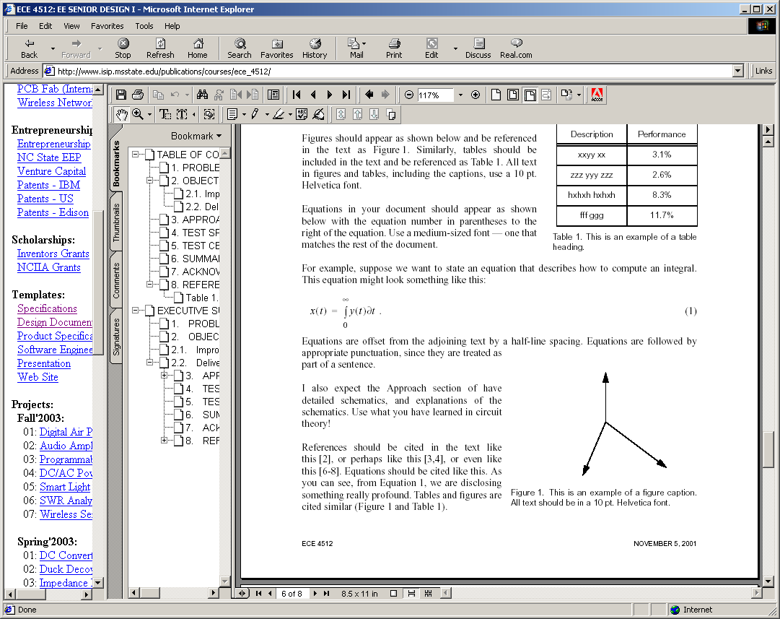

Figure 1. This is an example of a figure. Captions are justified when they are multiple lines, and centered if they are one line. Captions should be no more than about three lines.

For example, below, in Figure 1, we can see some interesting experimental results. This results are supported by the all important equation of life:

 ()

We can see in Equation (1) that the mystery of life is explained.

## Hardware Design

Each project will describe their hardware and software designs in major sections. Hardware design should begin by developing a block diagram of the overall system, and then expanding on the theory and design behind each one of these blocks.

Some interesting text goes here… Some interesting text goes here… Some interesting text goes here… Some interesting text goes here… Some interesting text goes here… Some interesting text goes here… Some interesting text goes here… Some interesting text goes here… Some interesting text goes here… Some interesting text goes here… Some interesting text goes here… Some interesting text goes here… Some interesting text goes here… Some interesting text goes here… Some interesting text goes here… Some interesting text goes here… Some interesting text goes here… Some interesting text goes here… Some interesting text goes here… Some interesting text goes here…

### Theory of DC Power Supplies

Some interesting text goes here… Some interesting text goes here… Some interesting text goes here… Some interesting text goes here… Some interesting text goes here… Some interesting text goes here… Some interesting text goes here… Some interesting text goes here… Some interesting text goes here… Some interesting text goes here… Some interesting text goes here… Some interesting text goes here… Some interesting text goes here… Some interesting text goes here… Some interesting text goes here… Some interesting text goes here… Some interesting text goes here… Some interesting text goes here… Some interesting text goes here… Some interesting text goes here…

### More Interesting Theory

Some interesting text goes here… Some interesting text goes here… Some interesting text goes here… Some interesting text goes here… Some interesting text goes here… Some interesting text goes here… Some interesting text goes here… Some interesting text goes here… Some interesting text goes here… Some interesting text goes here… Some interesting text goes here… Some interesting text goes here… Some interesting text goes here… Some interesting text goes here… Some interesting text goes here… Some interesting text goes here… Some interesting text goes here… Some interesting text goes here… Some interesting text goes here… Some interesting text goes here…

## Software Design

We will go through a formal software design process in class. You can use most of this material for your software design. More details will be given on this during classroom lectures.

Some interesting text goes here… Some interesting text goes here… Some interesting text goes here… Some interesting text goes here… Some interesting text goes here… Some interesting text goes here… Some interesting text goes here… Some interesting text goes here… Some interesting text goes here… Some interesting text goes here… Some interesting text goes here… Some interesting text goes here… Some interesting text goes here… Some interesting text goes here… Some interesting text goes here… Some interesting text goes here… Some interesting text goes here… Some interesting text goes here… Some interesting text goes here… Some interesting text goes here…

# EVALUATION

This section contains two major sections.

## Test Specification

Describe in detail what tests you will run to verify your design constraints. I expect three subsections for simulation, hardware, and software.

## Test Certification – Simulation

Describe how you used simulations to verify your design.

## Test Certification – Hardware

I expect two subsections here: one for the prototype and one for the packaged version.

## Test Certification – Software

Again, two subsections for the prototype and packaged system.

# SUMMARY AND FUTURE WORK

This section will be about one page long and review what was accomplished (what worked? what didn’t work?), and talk about future extensions of the project (what things could be done better? what things needed to be done differently to overcome problems).

# ACKNOWLEDGEMENTS

We wish to acknowledge John Doe of ABC Corporation, Dr. John Smith of the National Institute

for Cool Things, and Dr. I.M. Smart of XYZ for their continued support and feedback regarding this project. We also acknowledge the National Science Foundation for its funding of this project, which enables many useful on-line documents to be developed. Mr. Doe’s interactions have helped us add features to the system, some of which make this system very unique compared to other systems. Say a few more good things.

# REFERENCES

Anderson, A. K. (2005). Affective influences on the attentional dynamics supporting awareness. *Journal of Experimental Psychology: General*, *154*, 258–281.

Anderson, A. K., Christoff, K., Panitz, D., De Rosa, E., & Gabrieli, J. D. E. (2003). Neural correlates of the automatic processing of threat facial signals. *Journal of Neuroscience*, *23*, 5627–5633.

Armony, J. L., & Dolan, R. J. (2002). Modulation of spatial attention by fear-conditioned stimuli: An event-related fMRI study. *Neuropsychologia*, *40*, 817–826.

References must follow APA format. There are many good sites that describe these standards. Here are two that I find very useful:

<http://en.wikipedia.org/wiki/APA_style>

<http://flash1r.apa.org/apastyle/basics/index.htm>

Your overall reference list should be close to 50 items, with at least 25 of these coming from peer-reviewed journals and books.

1. Product SPECIFICATION

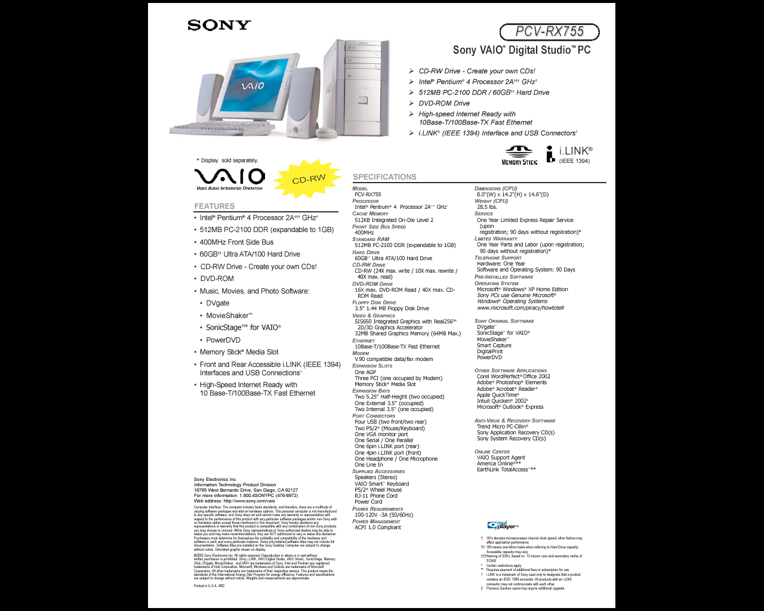

1. SOME INTERESTING RELEVANT DERIVATION

Software listings are generally NOT included in the document. These should be on the web site and referenced from the document using a URL.

It is common, however, to want to discuss a specific point or derive an important relationship. Such details, when not immediately relevant to the document, are best included as appendices.